1. **MODERN WEB DEVELOPMENT STANDARD**

As a leader in our community, our government should provide the services that we need. Government can now provide digital services by the use of technology nowadays. For example, creating a website that provides information about the government's services, policies, and announcements, etc.. However, Before creating government's website, you should consider the best practices and guidelines set by W3C and other organizations:

* **Guidelines for website’s page layout, navigation and structure**
  + Government's web page design should be informative, attractive and the content should be clear and organized.
  + The website's navigation should be easily navigated.
  + Avoid using distracting animations and unnecessary elements.
  + The Page layout should be consistent and maintained throughout the site.
  + The Placement of navigation bar should be maintained and placed on one area.
  + Make the structure simple by following the three clicks principle.
  + The website shall establish a clear web content, web structure and maintain information flow in such a way that users can use the website easily..
* **Guidelines for website’s content**
  + Government's website content should convey direct message, It should be accurate and uses simple language in order for the users to understand the message clearly.
  + Ensure that the website is free from grammatical and spelling errors.
  + If possible, avoid using acronyms and abbreviation.
* **Guidelines for website’s graphics and color content**
  + The website should use thumbnails in displaying large graphics.
  + The website's graphics should be captioned and labeled properly.
  + The website's background images / background color should be simple, appropriate and blend to the content and design of website.
  + When choosing a background color in a government website, choose the color/ color combination that shows professionalism.
  + Use colors which match the color theme throughout the whole website for consistency.
    1. **COMPARATIVE EVALUATION**

Designing a government website is controversial since there's a lot of modern web standards and practices that we need to follow. Using the different tools, we can now evaluate a particular website if it meets the w3c standards.

1. **National Economic and Development Authority Website**
   * **Wave Report**

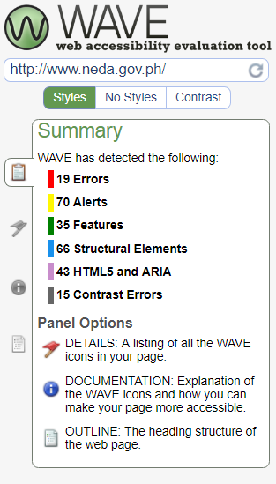

* + **AChecker**

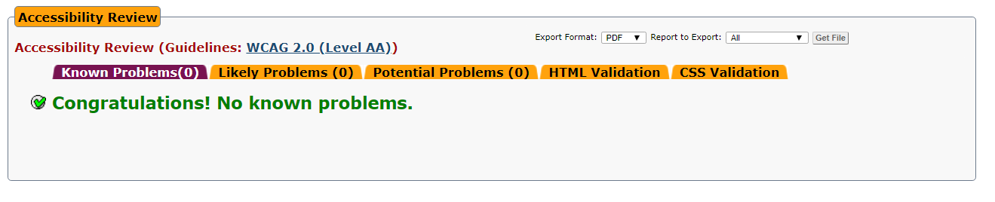

* + **W3C Checker**

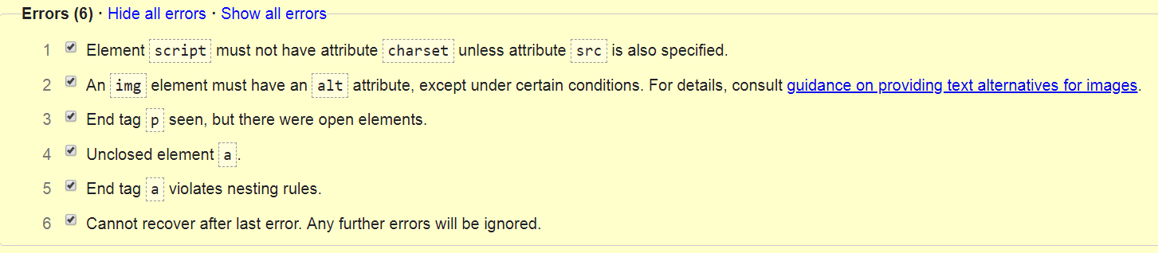

**2. Commission on Higher Education Website**

* + **Wave Report**

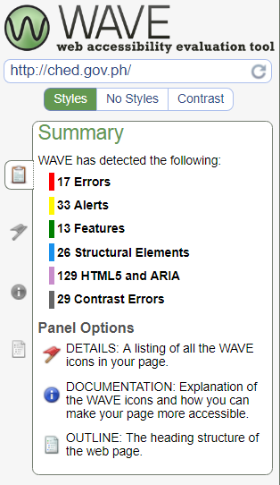

* + **AChecker**

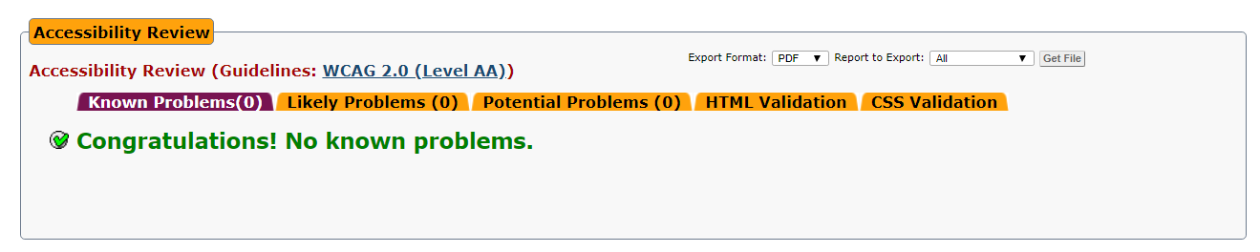

* + **W3C Checker**

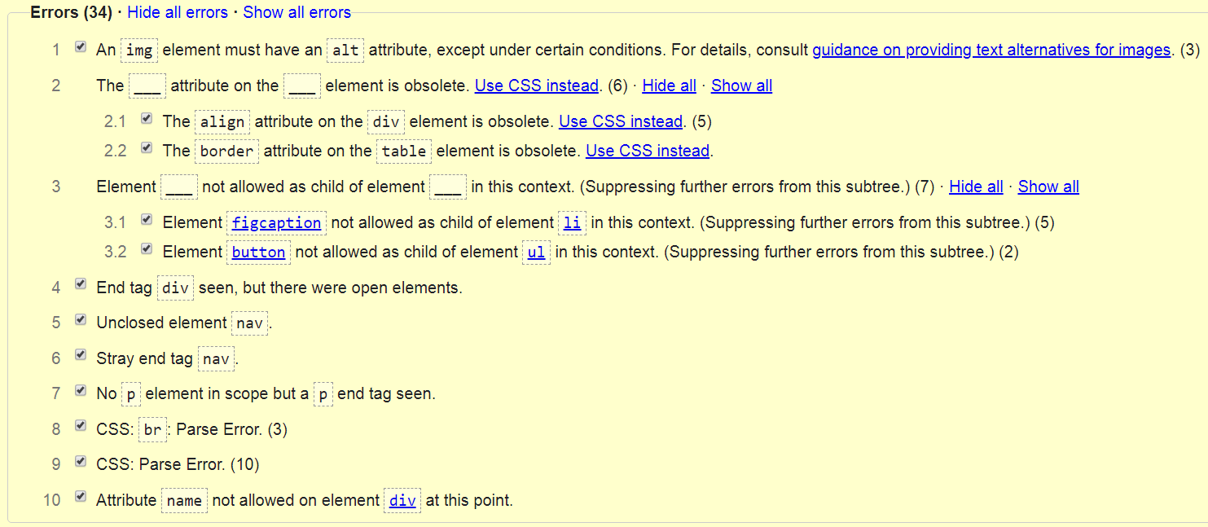

**3. Food and Drug Administration website**

* + **Wave Report**

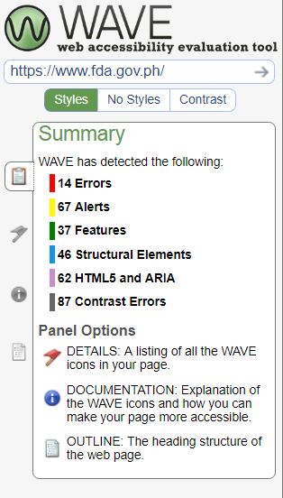

* + **AChecker **
  + **W3C Checker**

